## 

## Assignment

1. List the total number of projects that employees who work on it make less than $50k. (*Hint: You need to use keyword DISTINCT in this query. Can you tell me why?).*

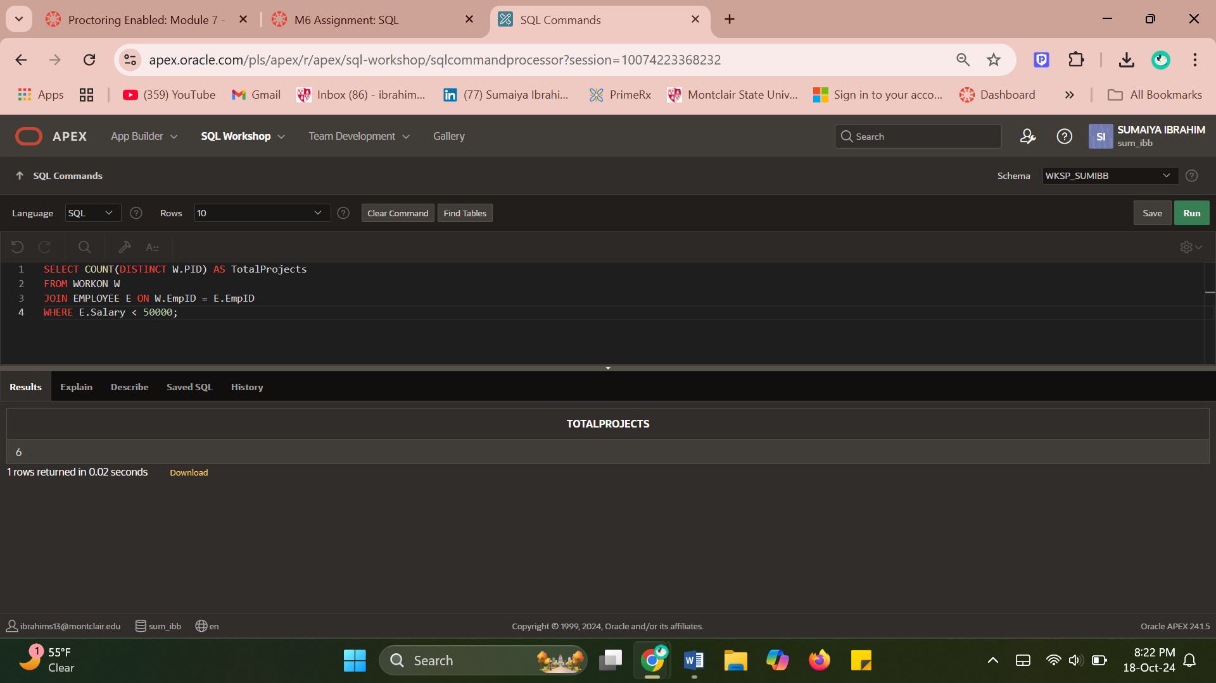

Even though there can be several employees working on a given project earning less than $50,000, this query needs the DISTINCT term to count each project only once.

If DISTINCT was not applied and several workers on a single project received salaries under $50,000, that project would show up in the results multiple times, once for each eligible worker. The projects would be overcounted as a result.

Since I'm using DISTINCT, it will only be counted once if many people make less than $50,000 on the same project. With the aid of the keyword DISTINCT, it therefore prevents duplication and provides a suitable count regarding unique projects.

For instance, without DISTINCT, a project would be counted twice if two workers with wages under $50,000 were engaged in it. If DISTINCT was not applied and several workers on a single project received salaries under $50,000, that project would show up in the results multiple times, once for each eligible worker. The projects would be overcounted as a result.

1. List the total number of projects and total budget for each division, show division name. (*Note Some divisions may not have projects, you still need to show this division in result.)*

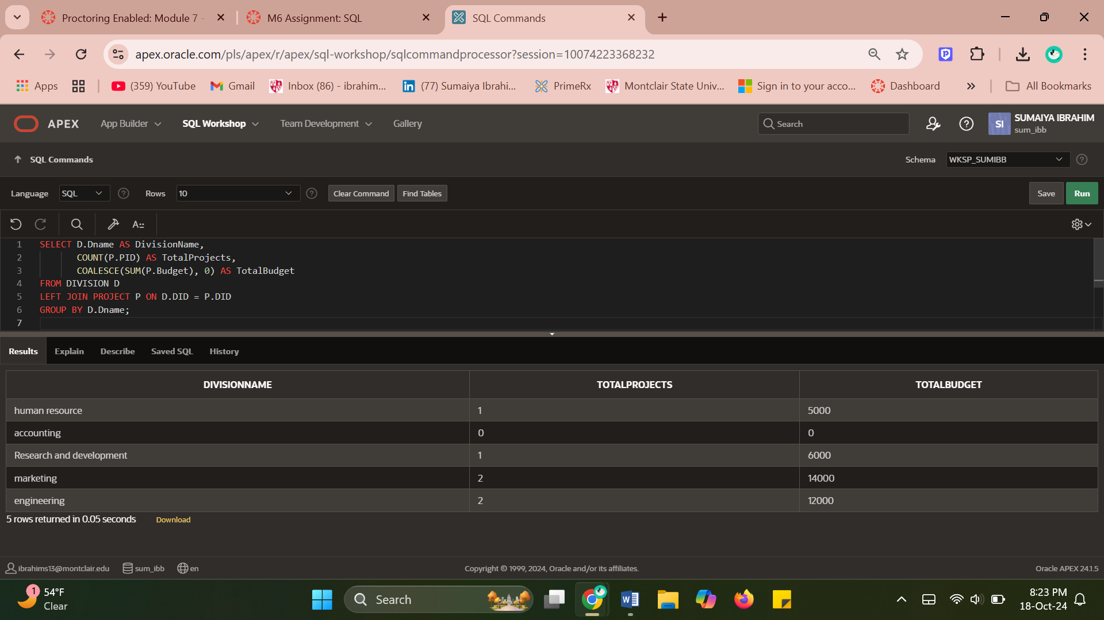

1. For each project, list its name and total number of employees who work on that project.

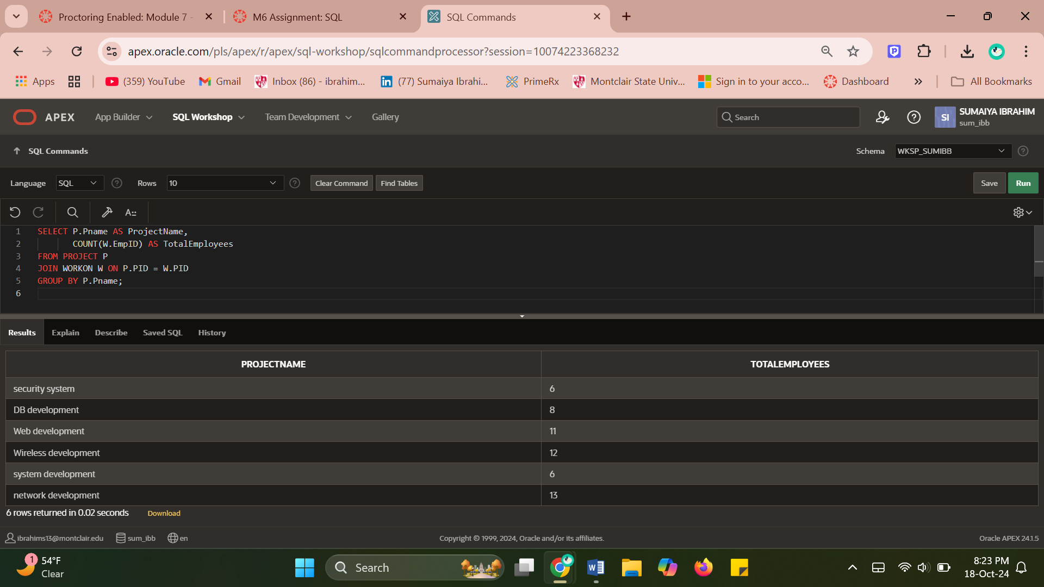

1. List the name and ID of employees that worked on more than one project. (*Note :  there are some employees who have same names*).

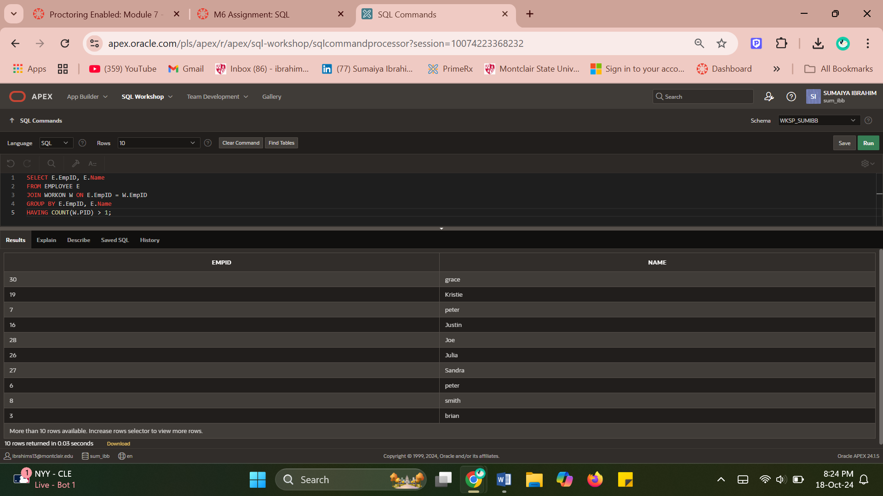

1. List the total number of project each employee works on, including employee's name (*note :  there are some employees who have same names and some employee may not work on any project*).

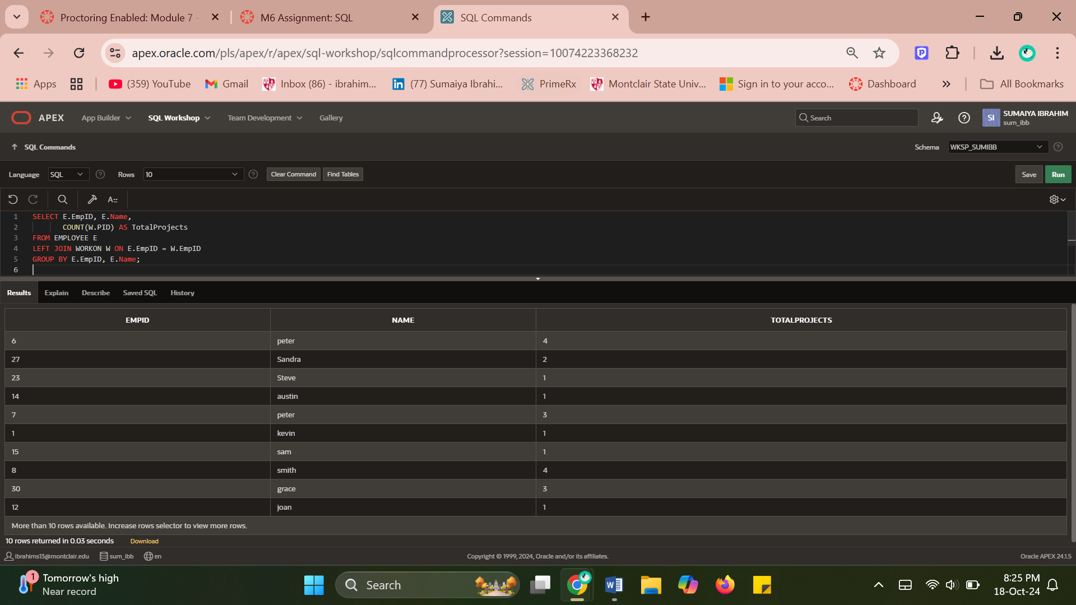

1. List the total number of employees who work on project 'Web development'.  Also list the total working hours for this project.

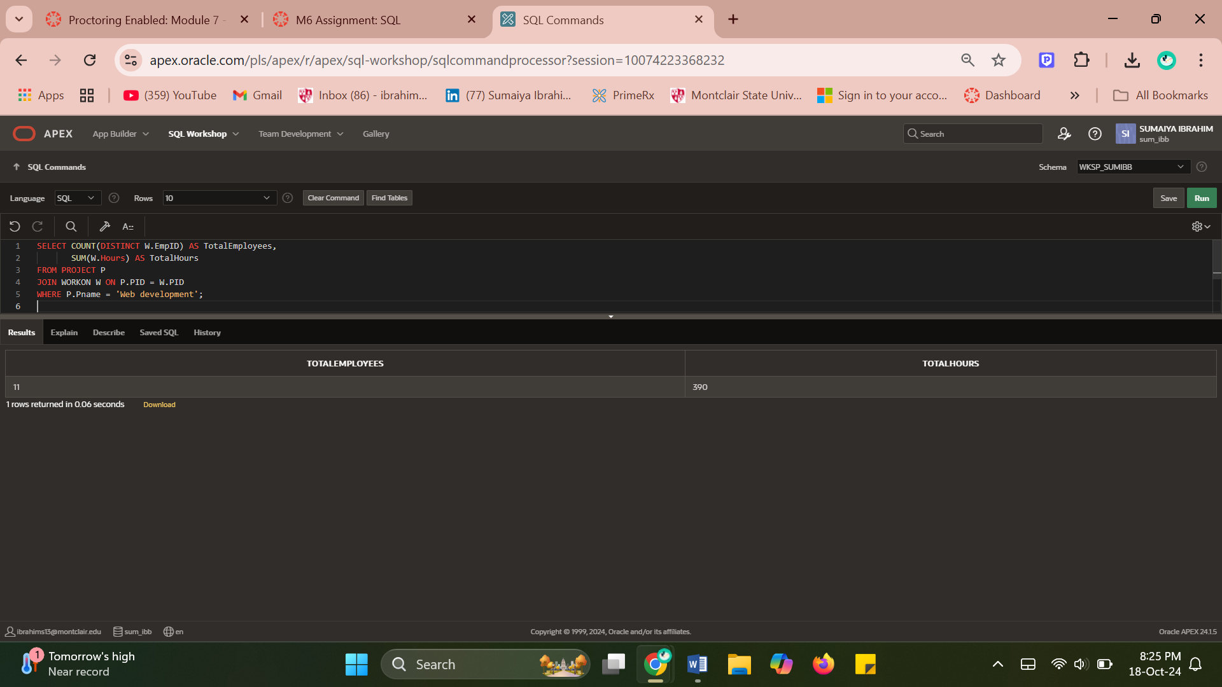

1. List the name of the project that 'chen' works on. (*Hint: join 3 tables*)

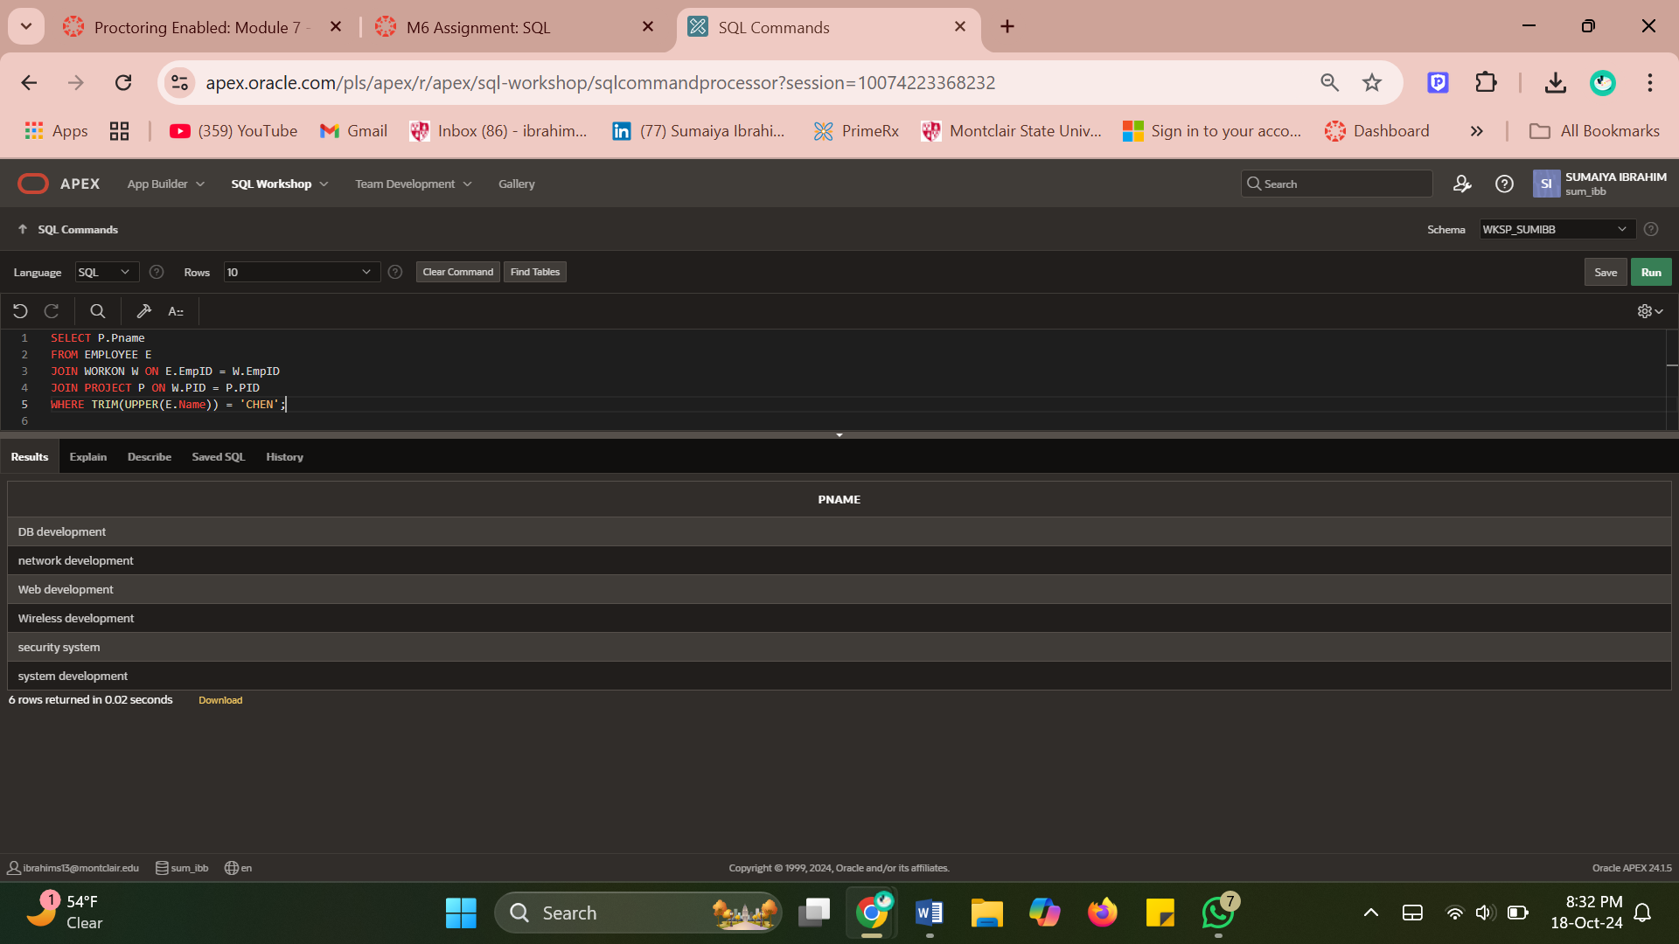

1. List the name of the manager who works on some projects. (Note, managerID is empid of an employee who is a manager)

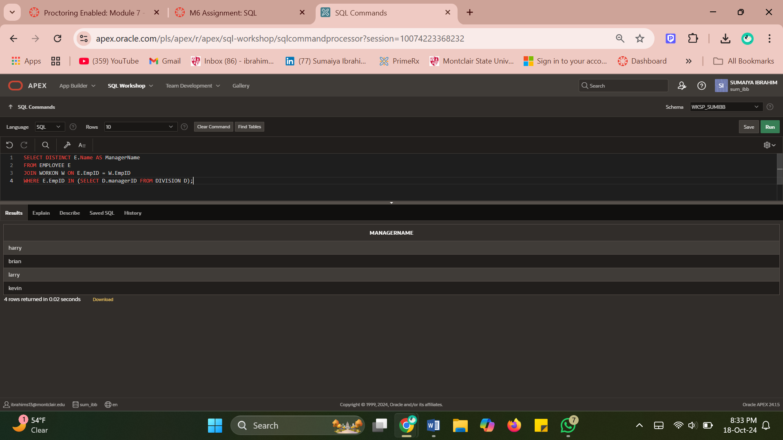

1. List the name of the employee and his/her salary, who work on any project and salary is below $40000. (*Note:  don't duplicate an employee in the list)*

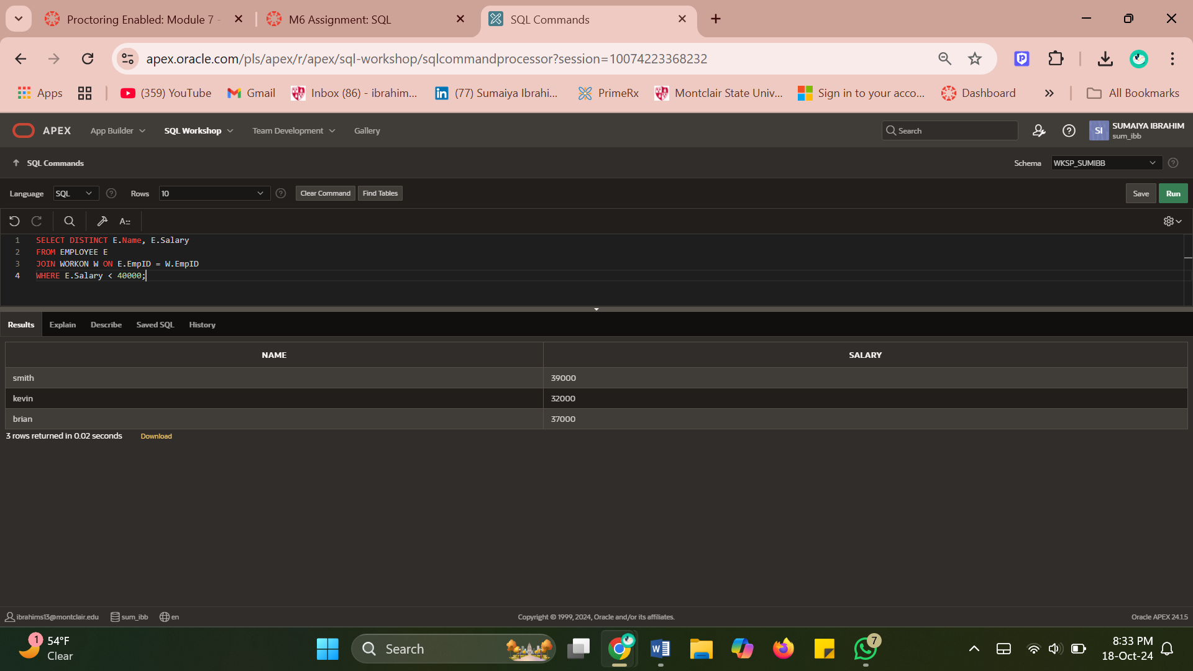

1. List the name of the employee who works on one or more projects with a budget over $5800. *(Note:  don't duplicate an employee in the list)*

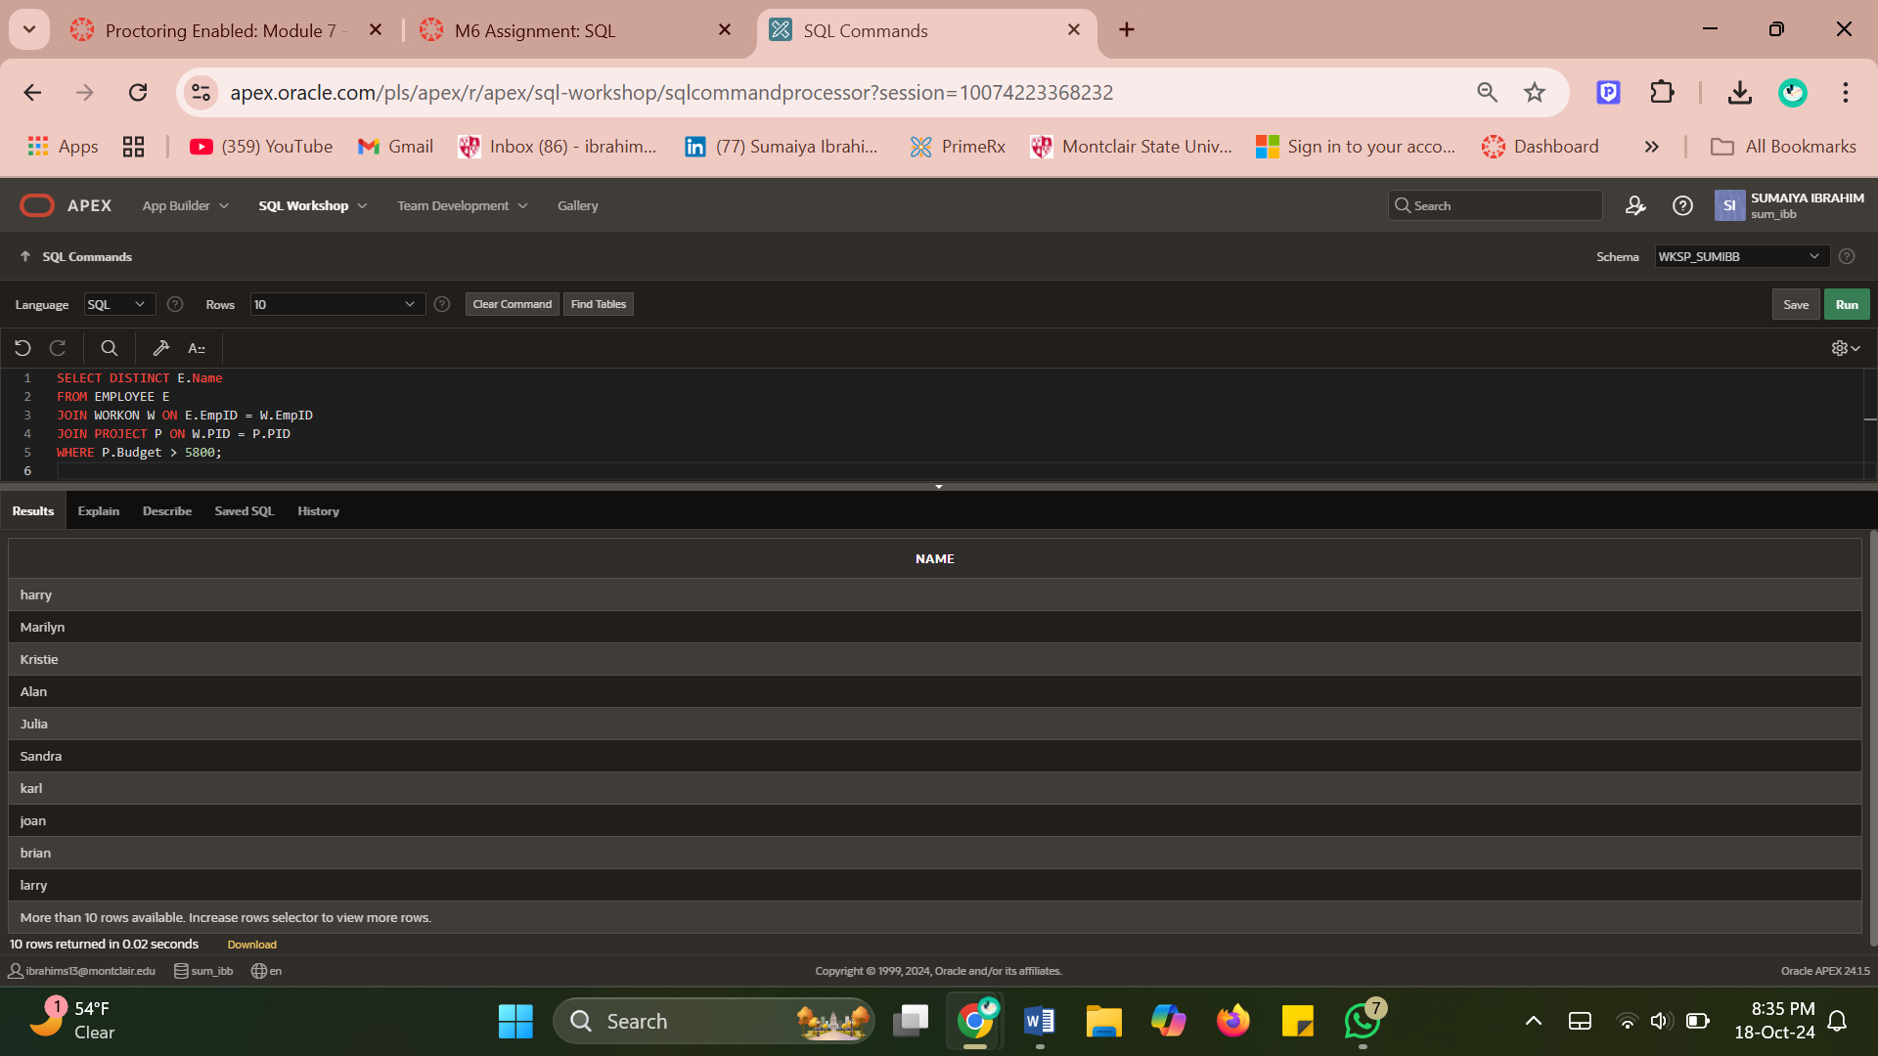

1. List the names that are shared among employees.

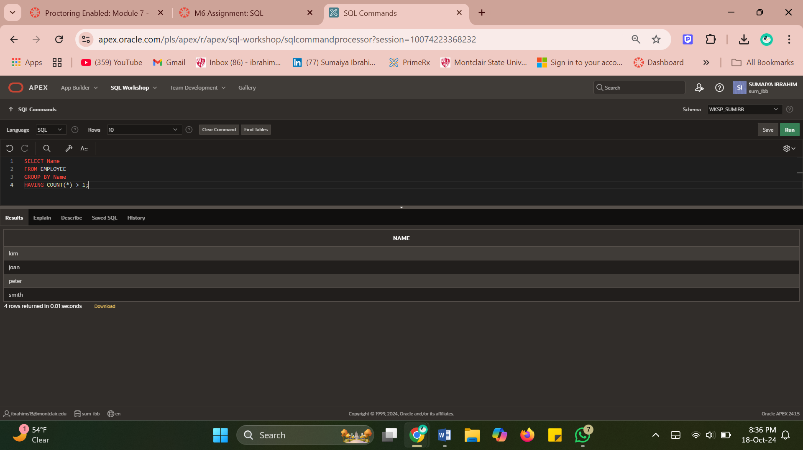

1. List the name of the employee if he/she works on a project with a budget that is less than 10% of his/her salary. (Hint: join 3 tables)

**(Bonus)**

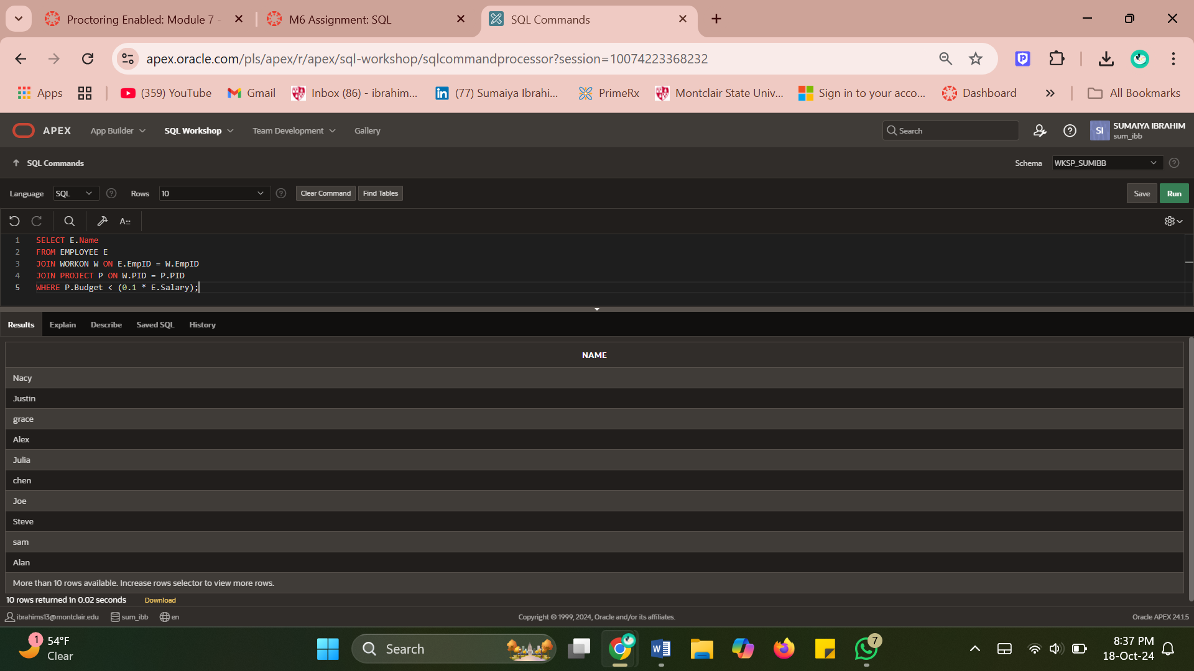

1. Run the following code to learn the use of concatenator ||

Select 'employee ' || name || ' of Division '|| DID || ' earns $' || salary AS "Employee Report"

From employee e

Order by did

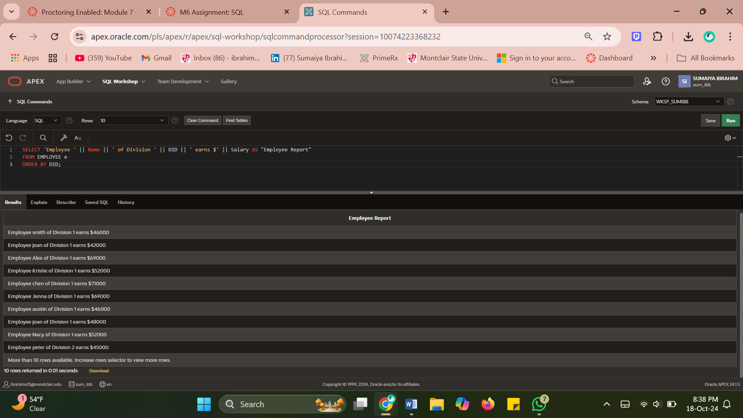

Use what you learned from above code to create result show as the follows (*Hint use UNION operation)*

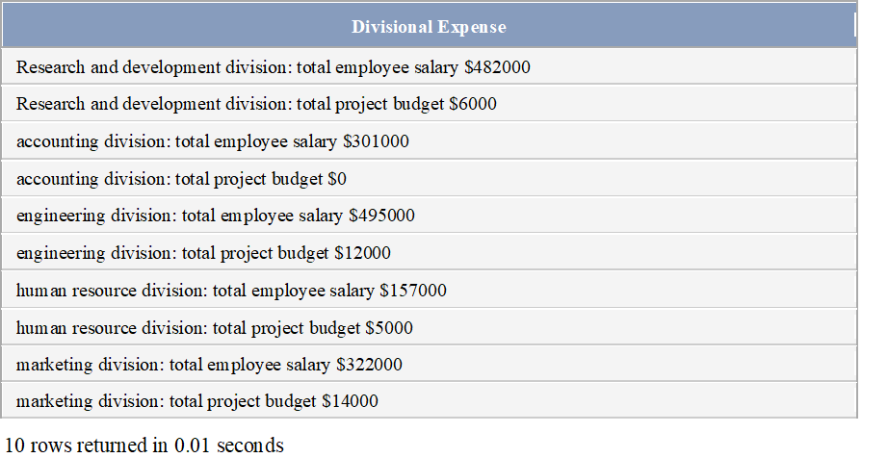

1. Use INTERSECT operation to list the name of project chen and larry both work on.

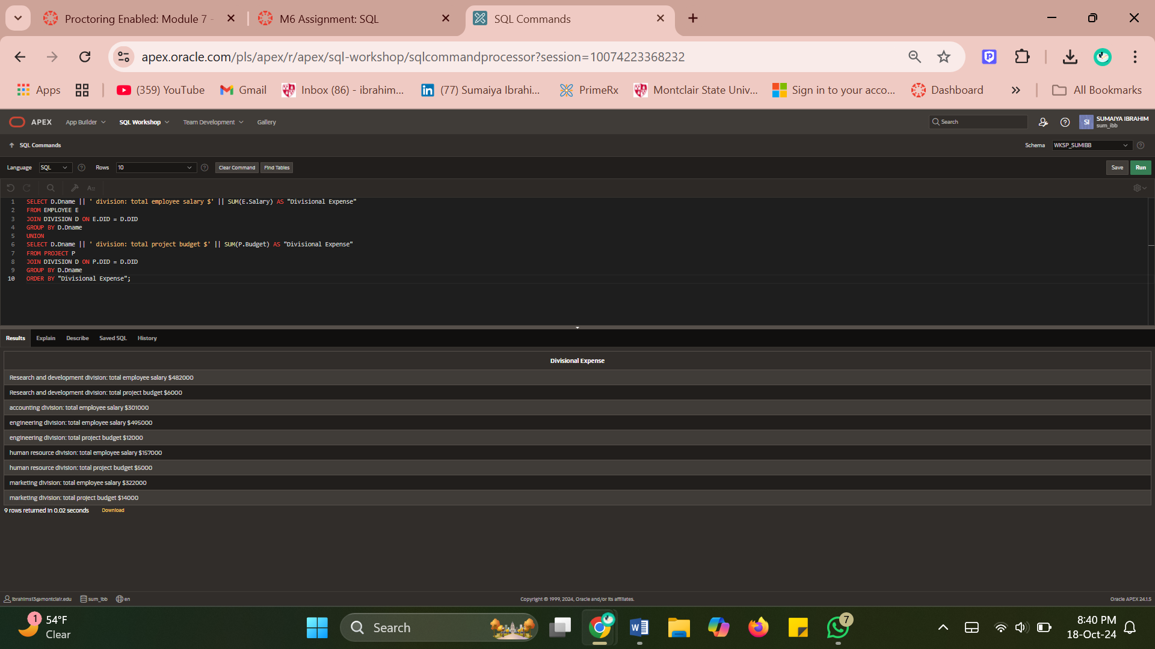

1. Use MINUS operation to list the name of the project Chen works on but Larry does not.

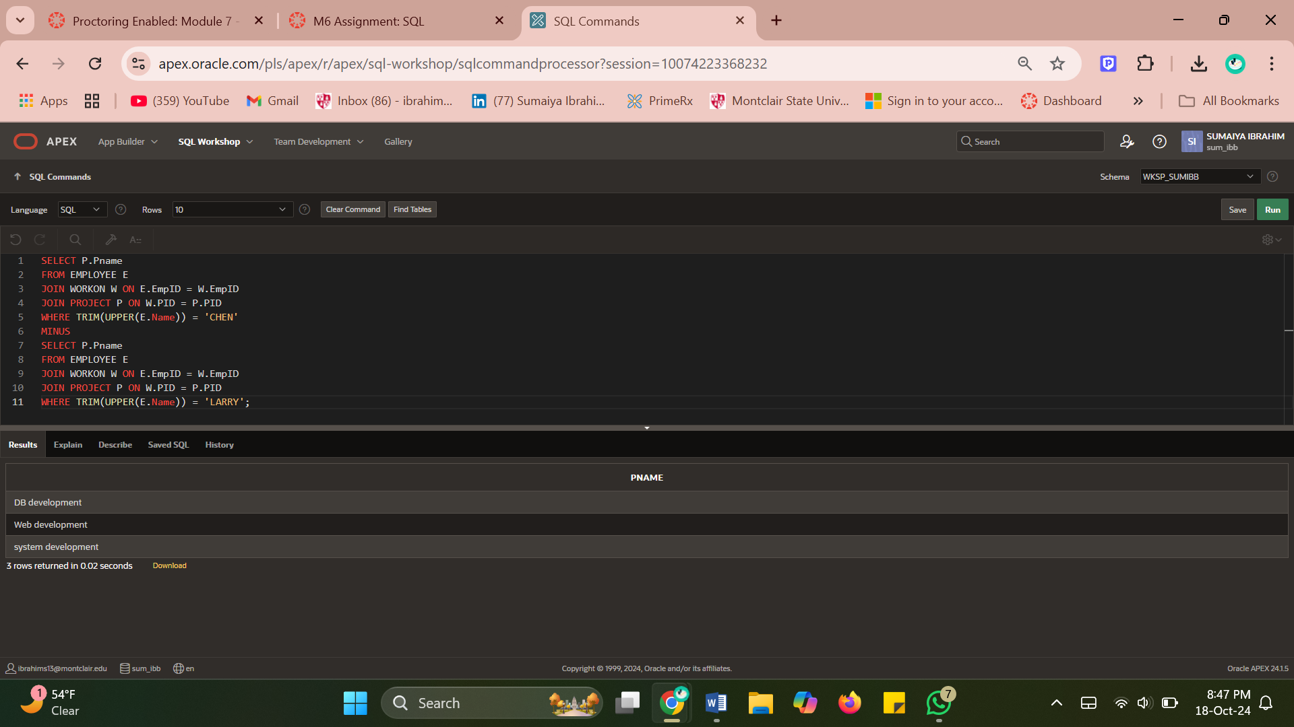

1. List the name of employee whose salary is over company's average salary *(hint: use sub-query)*

